

Business Requirements
Shopper’s Den

Table of Contents

1 Introduction 1
1.1 Purpose 1
1.2 Scope 1
1.3 Definitions, Acronyms, and Abbreviations 1
1.4 References 2
1.5 Overview 2
2 Project Vision 3
2.1 Problem Statement 3
2.2 Statement of Business Need 3
2.3 Project Objectives 4
2.4 Success Criterion 4
3 Project Scope 5
3.1 Project Scope and Boundary 5
3.1.1 Project Inclusion Statement: 5
3.1.2 Project Exclusion Statement 5
4 Current Business Process 6
4.1 Current Process Flow 6
4.2 Current Architecture 7
4.3 Limitations of the Current Process 7
5 Business Requirements 7
5.1 Proposed Process Flow 7
5.2 Business Benefits 8
5.3 Detailed Business Requirements 8
6 External Interface Requirements 9
7 Operating Environment Requirements 9
7.1 Hardware 9
Processor: 500MHz or above 9
7.2 Software 9
7.3 Network 9
7.4 Communication 9
8 Quality Attributes 10
9 Standards Requirements 11
9.1 User Interface 11
9.2 Detailed Design 20
10 Stakeholder and User Descriptions 30
10.1 Stakeholder Profiles 30
10.1.1 <Student> 30
10.2 User Profiles 30
10.2.1 <Employee> 30
10.3 User Environment 31
11 Assumptions and Constraints 31
Appendix 31

Document Revisions
Date | Version | Description | Author

Note: These documents are strictly for Virtusa/the specific client use only. They shall not be shared with an external party other than the client concerned. These documents should always be kept securely and employees shall use reasonable care protecting these documents from unauthorized use or disclosure to a third party. This category also covers client intellectual property where Virtusa has a non-disclosure agreement with the client.

Document Approval

Virtusa Corporation and <Client> have reviewed this document and agree that the contents of the document are accurate. Any changes to this document must be communicated in writing, approved and signed off by both parties.

Signature | Signature
Date: | Date:
Name: | Name:
Client::<Client> | Virtusa Corporation

Template User Notes:

Help Info is provided (in blue italics) to describe what each section should contain. Sample Text is provided in some sections to assist the author in standard wording for common documentation. Macro Buttons (in blue italics) must be replaced to match the project, e.g. <Project.

Note: Help Info and Sample Text are included to provide guidance to the author and should be deleted before publishing the document.

Introduction

Purpose
This document describes the requirements of the business application ‘Shopper’s Den’, which depicts the B2C Catalogue Management.
B2C ordinarily refers to on-line trading, where companies and consumers interact electronically or digitally in some way. For example, online stock trading markets. The ultimate goal is the conversion of shoppers into buyers as aggressively and consistently as possible.
In this project the flow of information is between the business and consumer through the medium of Internet. It refers to marketing of a company’s products through the web. It may be done either to promote the company and its products and services or to actually sell the products/services through this virtual store.

Scope
The website should provide an opportunity for the user to buy the items online.

Definitions, Acronyms, and Abbreviations
Userid:user is uniquely identified by this id
Productid:product is uniquely identified by this id



References

www.sun.java.com
www.org.apache.com
www.w3schools.com
www.bestbuy.com
www.amazon.com
www.ebay.com
www.univercell.in

Overview
In this project, we provide an easy shop to the customers through which both the buyers and sellers get benefit of it.

Once he confirms the order, the user signs into his account using his user id and password. If the user is a new customer then he needs to register. Next he needs to enter his credit card details and shipping address. Once the transaction is over the products will be delivered to the customer on or before the delivery date.

If the users do not have a clear idea of the products that they want to buy they can use the search facility provided by the site.

If they have any particular doubts about the site they can use the effective help provided by the site.

The administrator who manages all the categories, log on to his account through his user id and password provided in the home page.

He can add category, delete category, add items based in the category, delete items based from the category , update the cost and also he can view the stock details and transactions..

Project Vision

Problem Statement
To assist the public in gaining an easier and faster way of shopping. Providing them with more options and real time information

The Problem | Online shopping
Stakeholders | Users
Impact | Purchase of items is made easy.
.Key Benefits | Convenient, timesaving, wide variety of products available.

Statement of Business Need
The aim of shopper’s den is to reach each and every customer and provide them with detailed information of the products. It also increases the flexibility in shopping.

Project Objectives

The project is useful for the users, who have credit cards.
One of the features is that at a single glance he can know details of the more number of items.

Success Criterion

Client has a very flexible way for maintaining the site. A login is being provided for the administrator to do the entire maintenance task. Client can have another login and buy the items on his choice.
Every user wants a flexible way of getting the work done. There is no need for a user to go through a long process to do the shopping.
Project meets the very requirement of the client to show the dynamic information to the user at any point of time.
If the user can select items so that they are added to the cart list and give his details like name, address, creditcard and confirm his order and can get his selected list to items to the shipping address, then it is measured as success.

Project Scope

Project Scope and Boundary

Project Inclusion Statement:

- If the user do not have a clear idea of the products that he want to buy he can use search facility.
- Customer can view the items according to the category wise.

- The user can update his account information.

- Administrator can add new products, update the products.

Project Exclusion Statement

- This project does not deal with the third party transactions.

- User has no privileges to act as seller.

Current Business Process

Current Process Flow

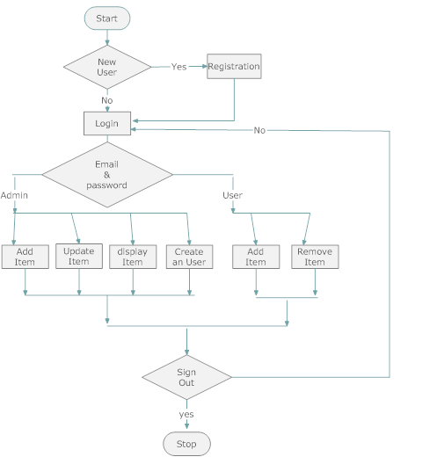

Current Architecture

DATA BASE TO BE SUPPORTED | ORACLE 9i
WEB SERVER | APACHE TOMCAT 5.0

Technical requirements:
Presentation Layer | HTML, CSS3, JSP with JSTL tags, jQuery for DOM/Form-Validation/AJAX Calls
Server Side | Spring MVC, Spring JPA (w) ORM, Spring Security(username & Token)
Application Server | Tomcat 8
Database | MySQL 8
IDE | Eclipse STS
JDK | Oracle JDK 8 64b
Build Management | Maven 3
Unit Testing | jUnit 5

Limitations of the Current Process

This process is limited to the users who have credit cards only. The site provides only a specific number of services. The future enhancement of this project may be site that maintains more number of items providing more facilities.

Business Requirements
Requirements are gathered to fill the communication gap between the client and developer. By gathering requirements; client can specify what he actually needs which helps the developers. Gathering requirements is always not that easy, indeed SRS forms the basic of software development. It should satisfy all the parties-something very hard to achieve – and involves trade –off and persuasion. It also helps the client to understand his needs and get the best out of the developer.

Proposed Process Flow
Process flow is shown in following flow chart.
Primary actors for this application are

- User
- Admin

Business Benefits

The proposed system is far more useful than the conventional method of manual shopping. User-friendly way of shopping attracts all kinds of users. All the services provided by this site are up to date.

Detailed Business Requirements

Document the business/high-level requirements and stakeholder needs. The business requirements can be documented as business-level use cases (a template needs to be there to support the business level use cases) or as a detailed narrative of the stated requirements. The requirements can even be numbered for traceability since they will manifest at a granular level when product component requirements are derived from it.

It will be also be preferable to summarize it by providing a list of requirements. For example:

Reqt. ID# | Description | Type | Priority | Status

Any other format can also be used to list the requirements. This will provide a basis to document the requirements and help in giving references, while discussing with the various user groups.

External Interface Requirements
External interface used for this application is simple web browser the user can access this application from any where from the world. Web browser like Internet Explorer can run this application effectively for windows.

Operating Environment Requirements

The software and hardware requirements are:

Hardware

Processor: 500MHz or above
Ram : 256Mb or above
Hard Disk: 40 GB or above

Software
Apache Tomcat 5.0
Jdk 1.8
Java Run Time Environment
Oracle 9i
Type 1 drivers
Browser (Edge/Chrome/FireFox Latest-10)
Enterprise Architecture
Image Reader

Network

Communication

Quality Attributes
A session Object is maintained for each and every user who logs in and that session is maintained until he logouts.
Security | SSL for Transport Layer  Username/Token(hashed) for User Security  Role based Authorization Privileges  Sensitive data @Session/@Request to be protected for integrity (ex Shopping Card Data, User Data, User Session etc)
User Base
  eCommerce Apps
  Total users | Concurrent Users | Y0Y Growth %
  5000 | 250 | 15%
  Admin Apps
  Total users | Concurrent Users | Y0Y Growth %
  100 | 25 | 20%
Performance | Peak Load Performance (during Festival days, National holidays etc)  eCommerce -< 3 Sec  Admin application < 2 Sec  Non Peak Load Performance  eCommerce < 2 Sec  Admin Application < 2 Sec
Availability | eCommerce – 100% Availability  Admin Application – 99% Availability
Standard Features | - Scalability  - Maintainability  - Usability  - Availability  - Failover
Logging & Auditing | - System should support logging(app/web/db) & auditing at all levels
Monitoring | - Should be able get monitored via as-is enterprise monitoring tools
Cloud | - The Solution should be made Cloud ready, and should have minimum impact when move away to Cloud in infrastructure
Browser Compatible | - IE Edge+  - Mozilla FireFox Latest – 15  - Google Chrome Latest – 20
External Cache | - Apply and implement external cache for avoiding costly repeatable IO Calls

Standards Requirements

User Interface

Home page

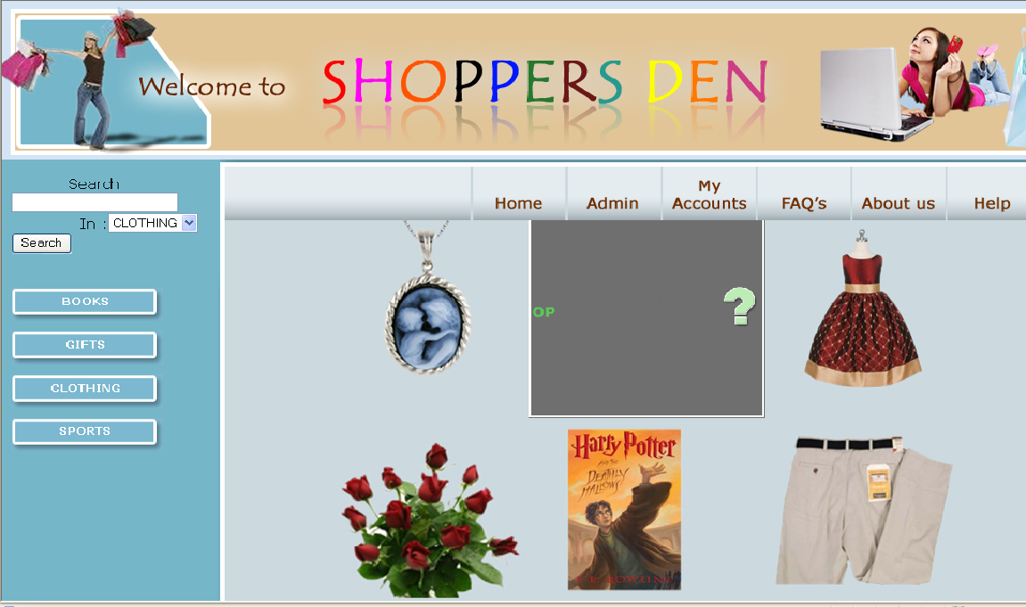

Registration

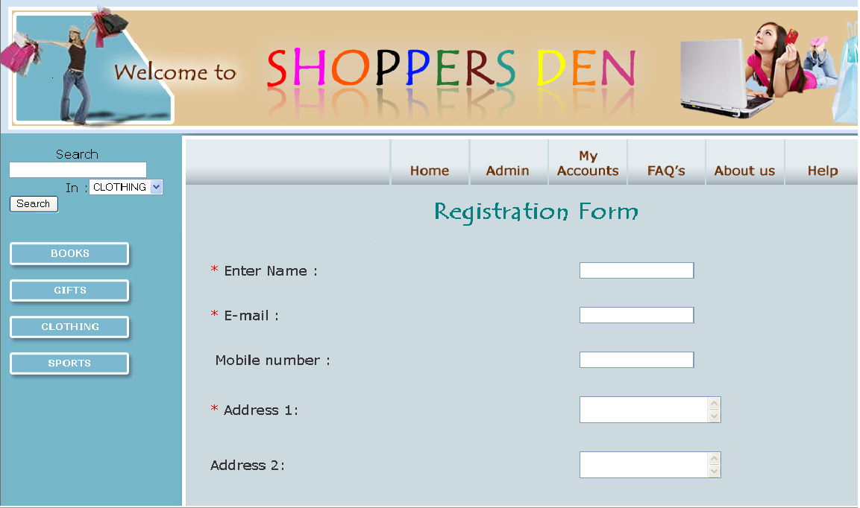

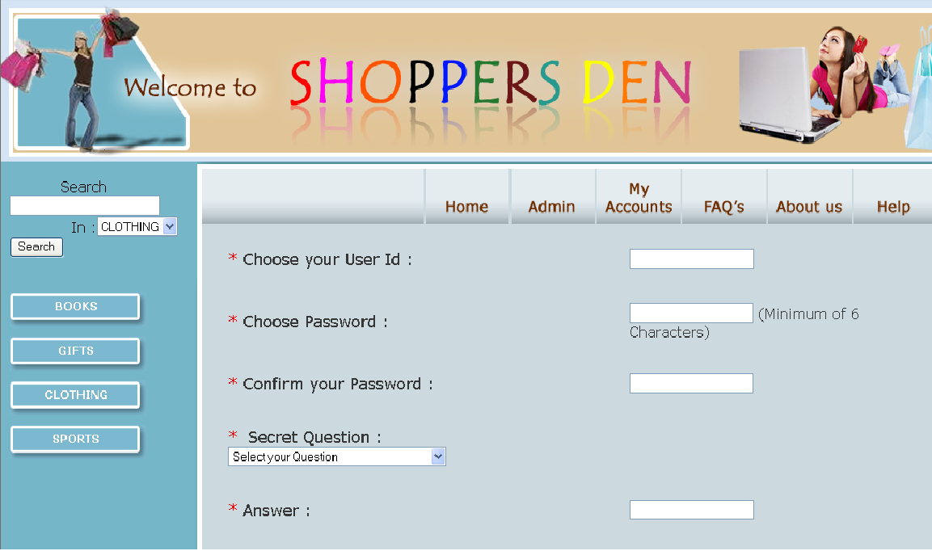

Login

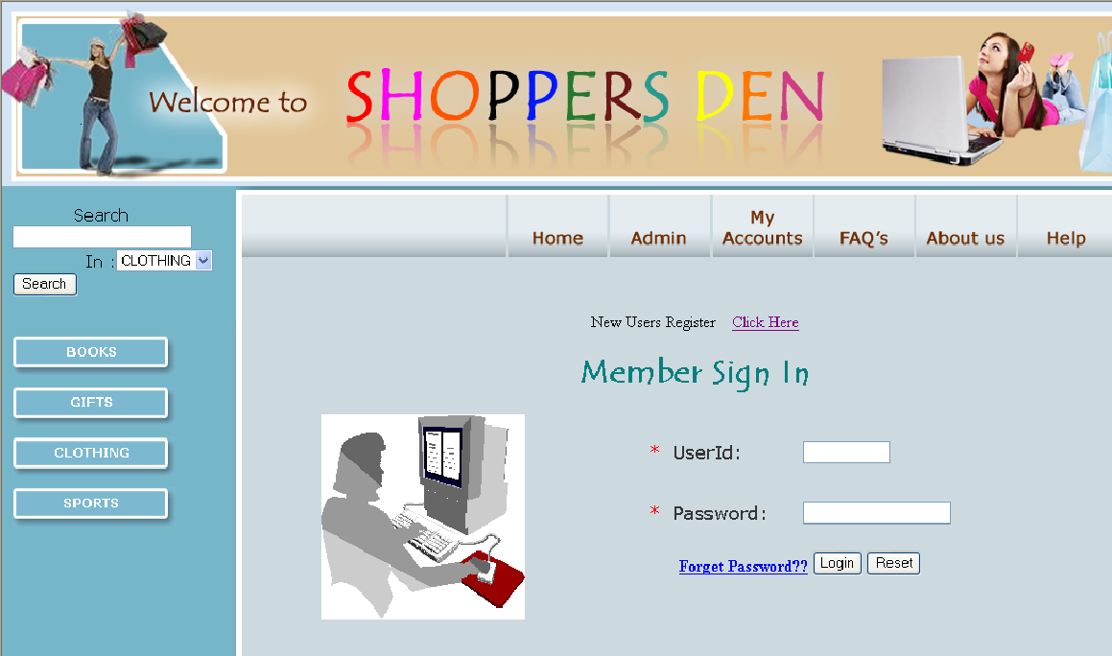

Display List

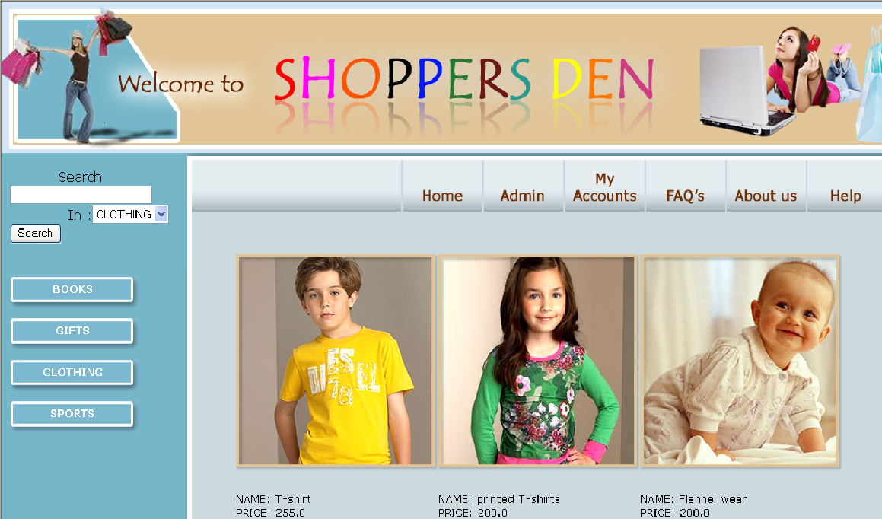

Billing Address

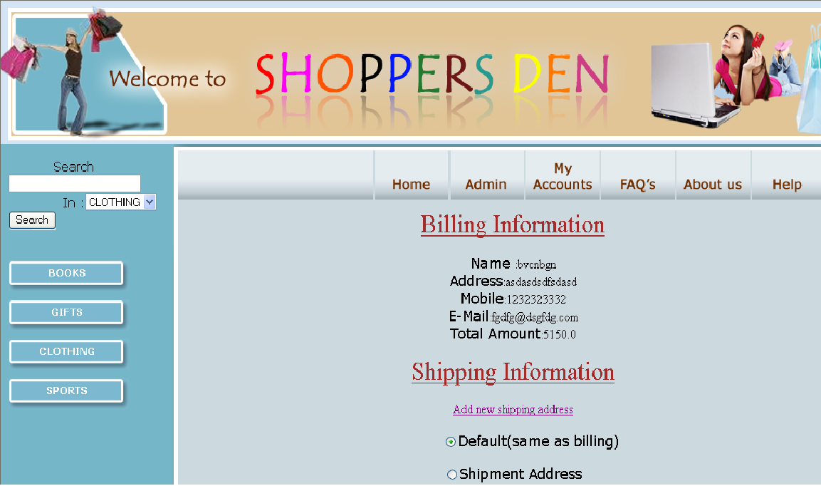

Payment information

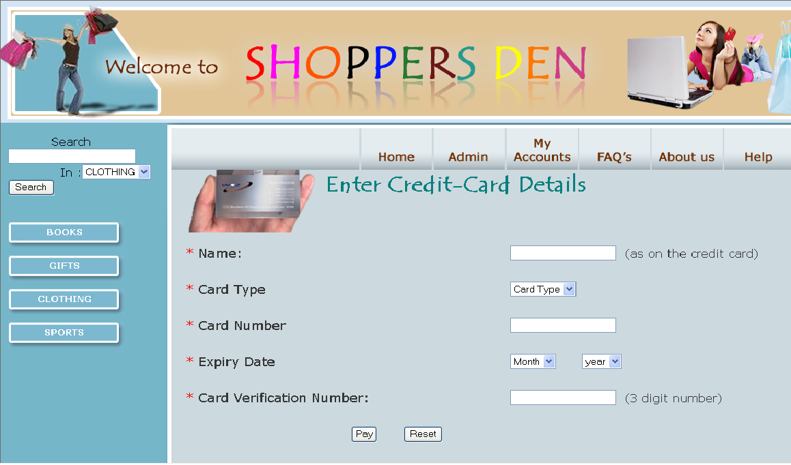

Admin Login Page

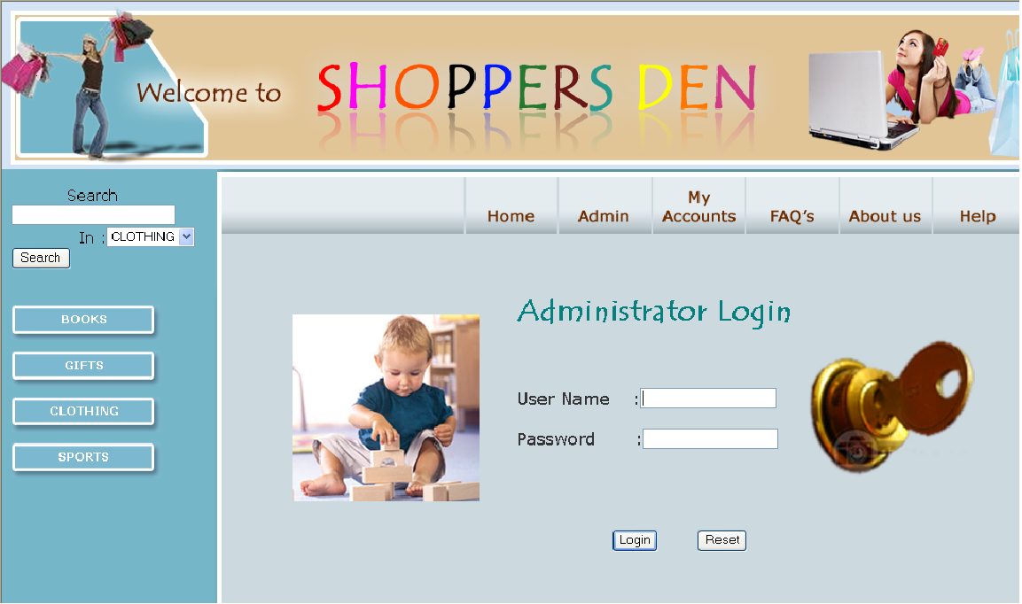

Admin Home Page

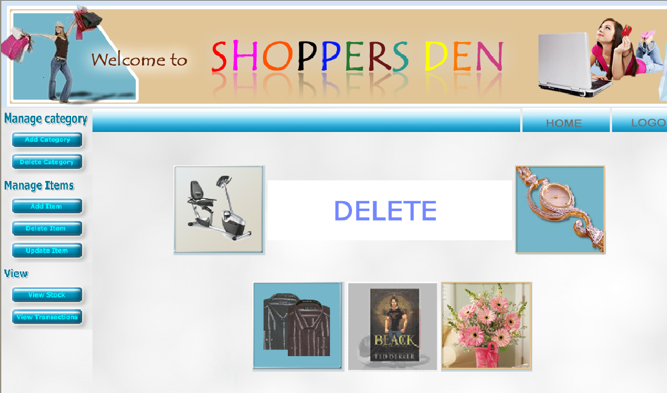

Detailed Design

Class Diagram:

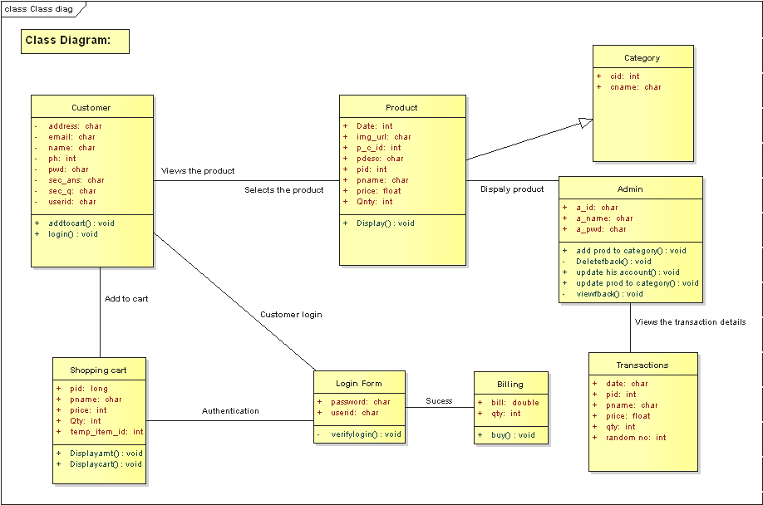

Use case diagram for user:

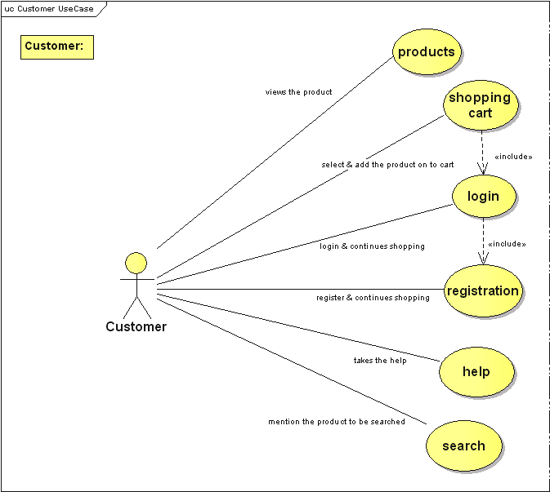

Use case diagram for administrator:

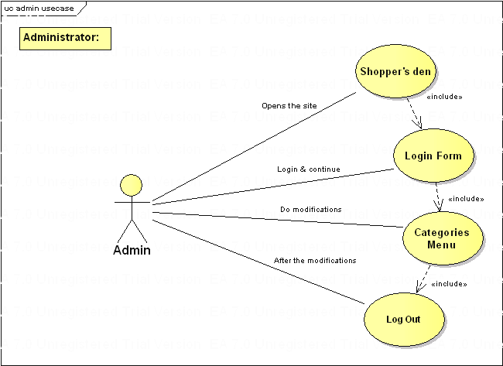

Sequence diagram for Registration:

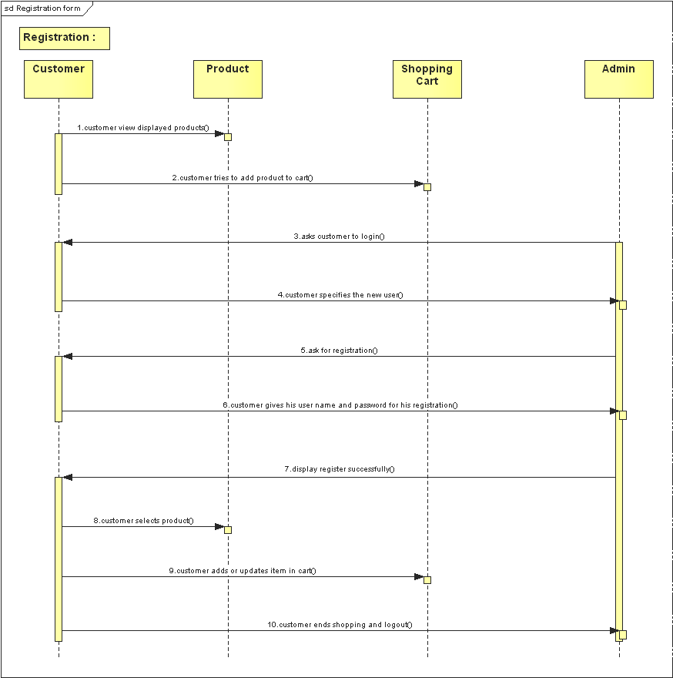

Sequence diagram for Customer Login form:

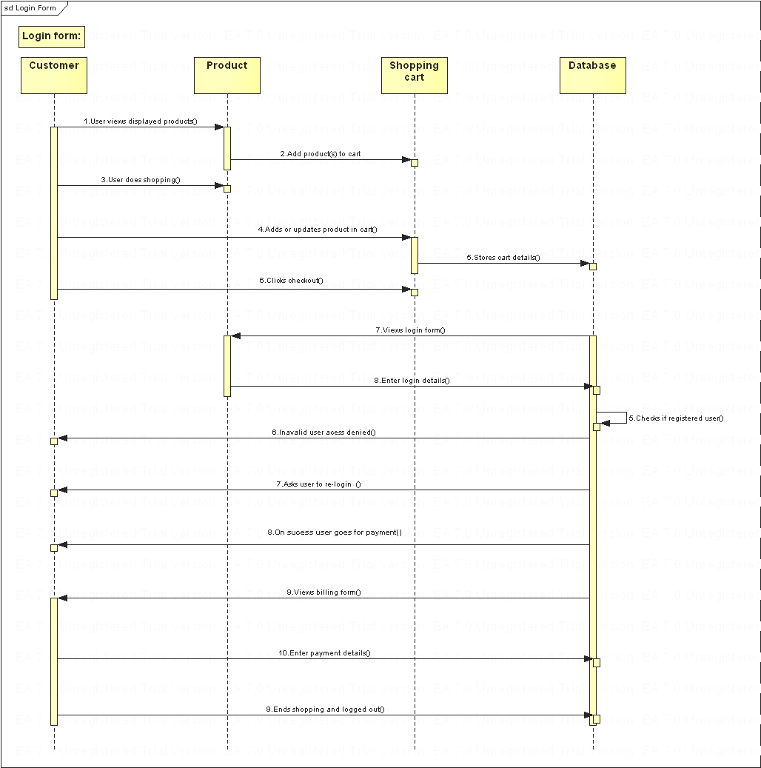

Sequence diagram for admin:

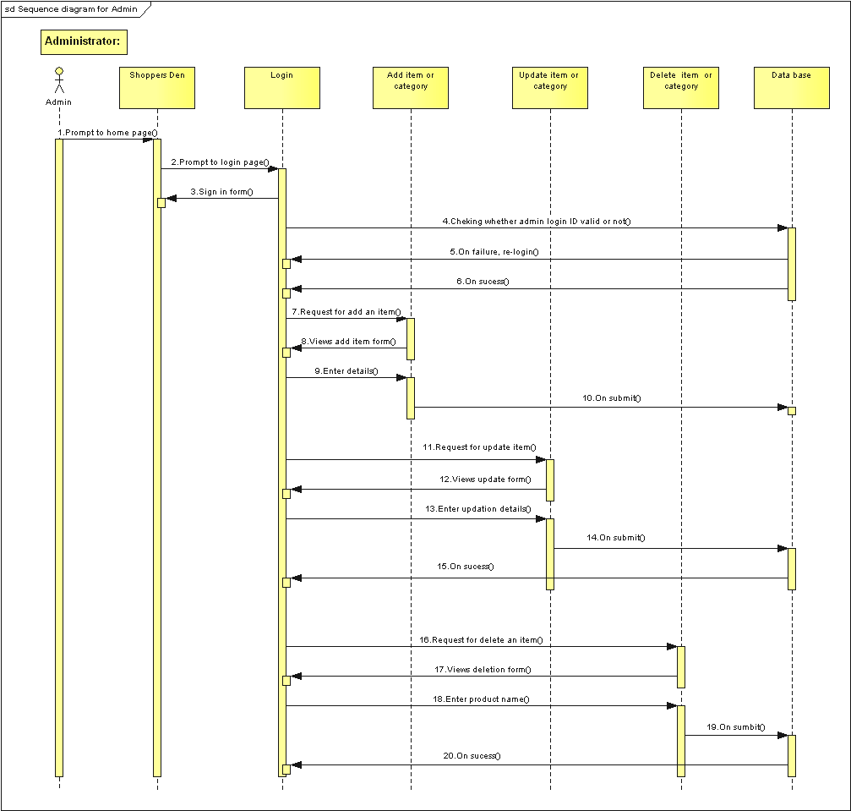

Sequence diagram for user:

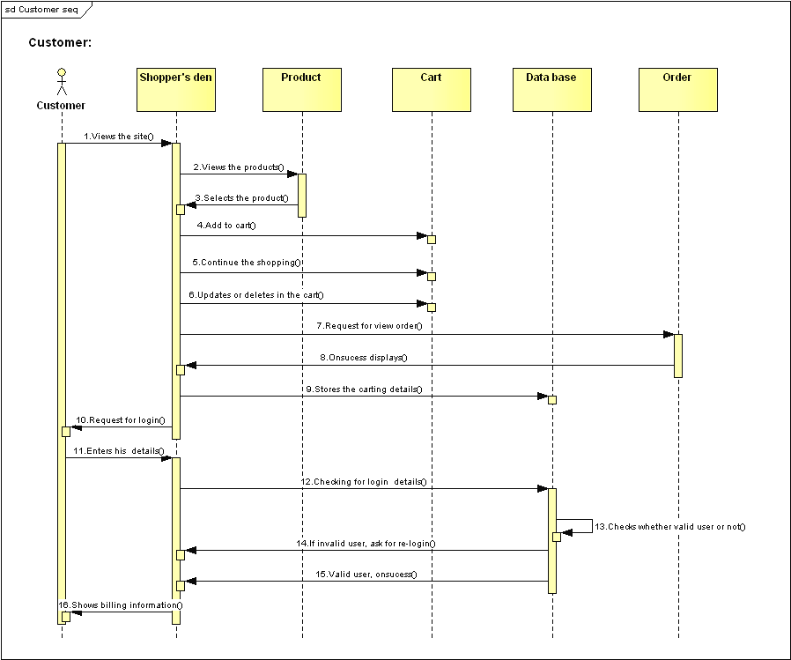

Activity diagram for user:

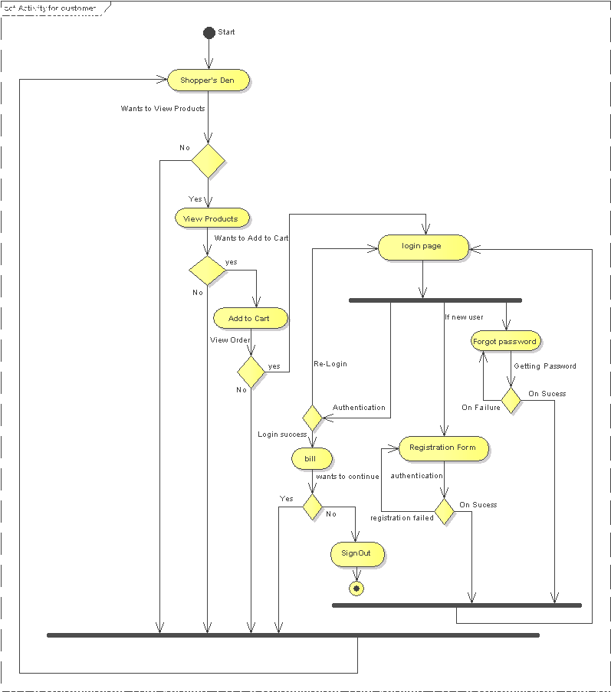

Activity diagram for administrator:

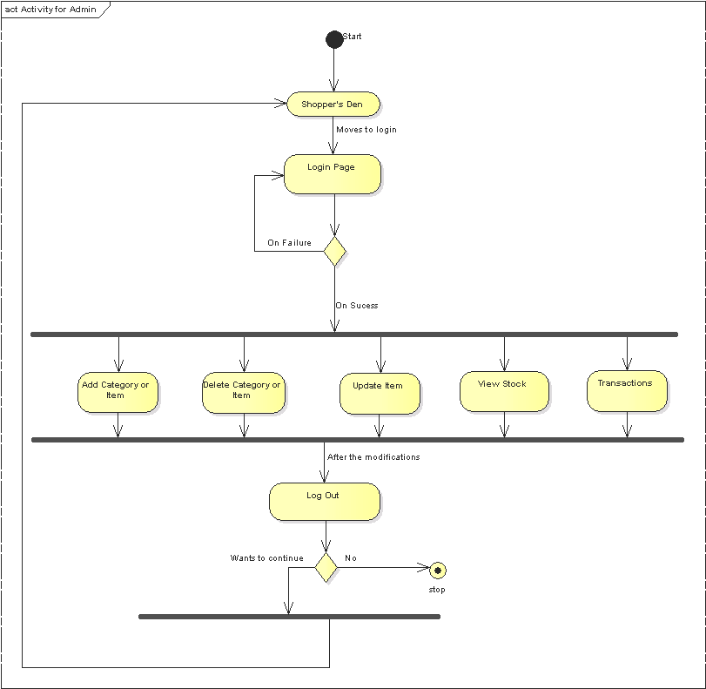

Stakeholder and User Descriptions

There are different users who use this application. Users may be employees, students, children etc

Stakeholder Profiles

<Student>
Representative | student
Description | Student can buy the items online.
Type | user know how to use this application and have credit card can buy the items.
Responsibilities | User want to buy the items with less effort
Success Criteria | User can add his selected items to cart ,provide his details, confirm his order and get the items to his shipping address is defined as success
Involvement | User use the application
Deliverables | Under development he don’t have any usage of system
Comments and Issues | User can put any issues after using this application

User Profiles

<Employee>

Representative | employee
Description | Employee has the basic knowledge regarding the application.
Type | Employee having credit card can buy the items.
Responsibilities | User want to buy the items with less effort
Success Criteria | User can add his selected items to cart ,provide his details, confirm his order and get the items to his shipping address is defined as success
Involvement | User use the application
Deliverables | no
Comments and Issues | User can put any issues after using this application

User Environment

Team of 7 people involved to complete this application. Each and every module is subdivided and developed by all the team members. Complete 15 days were allotted for these modules. The basic idea regarding this project is catalogue management. Advanced technology can be used to implement future enhancements.

Assumptions and Constraints

Appendix

